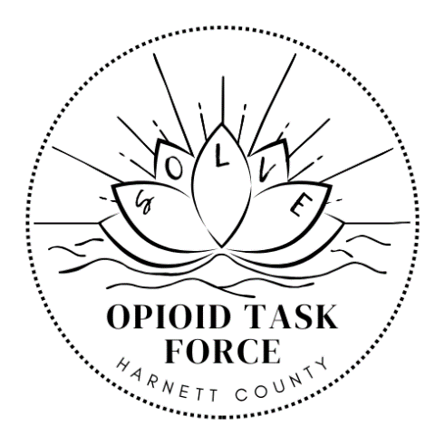
OPIOID TASK FORCE
Meeting Agenda
Resource Center and Library, Training Room 103
455 McKinney Pkwy, Lillington, NC
Oct 16, 2025
"The darkness of addiction cannot outshine the light of recovery."
- Introductions
  - Welcomes – Coley/Chris
  - Admin Updates – Charlie
    - We will have a few other counties at the task force meeting
      - Caitlyn Hewson – Pitt County Opioid Coordinator
      - Alyssa Kitlas – Wake County Opioid Coordinator
    - Impact report was filed for the year
    - Website Update – We have access and waiting for IT to complete the last part. Any updates, please send to me.
- Current Proposals
  - MOUD Training – Dr Hubbard
    - $1000 for 5 pharmacist to get training on injectable
    - $13300 for Both Stigma Reduction (Stigma Training) and Learning (Learning is Contagious).
  - Community Paramedics – Leslie and Jennifer
    - $10,550 for PORT safety kits
  - Health Department – Ainsley /Larry
    - $40,000 for Naloxone distribution over 2 years
Subcommittee Updates
  - Education and Prevention – Dr. Tillman/Dr. Rev. Rosa Smith Williams
    - “Recovering Hope Conference Tomorrow” – Coley/Dr Tillman
  - Treatment and Recovery – Dr. Agnello/Amy
    - Recovery Alive Updates – Amy/Tisha
  - Harm Reduction – Larry/Alex
    - NC HARM – Charlton/Gregg
- Closing
Task Force Success Stories – Coley/Chris
Next Meeting Dates
Education and Prevention – 13 Nov 2025 – 2pm
Treatment and Recovery – 10 Nov 2025 – 2pm
HARM Reduction -20 Nov 2025 – 2pm
Full Task Force 15 Jan 2026 – 2pm

Solveharnett.org

